**ASSINGMENT 1**

**Name: varna nemulla**

**Id: 700744920**

**#Question 1:** **Write a python program for the following: – Input the string “Python” as a list of characters from console, delete at least 2 characters, reverse the resultant string and print it.**

**Description:** In orderto complete this program, I used test_str and new_str variables and reversed () function. It deleted ‘h’ and ‘o’letters and reversed the whole string.

**– Take two numbers from user and perform at least 4 arithmetic operations on them.**

**Description:** To complete this code I have used two variables those are num1, num2 and if else statements. num1, num2 are the inputs for this program and Based on the input, program computes the result and displays it as output.

**#Question 2: Write a program that accepts a sentence and replace each occurrence of ‘python’ with ‘pythons’**.

**Description:** In this program we are supposed to the replace the word python with pythons for this I have used the function called replace (). So, based on the input, the program computes the result. It takes the input as python and displays the output as pythons.

**#Question 3:** **Use the if statement conditions to write a program to print the letter grade based on an input class score. Use the grading scheme we are using in this class.**

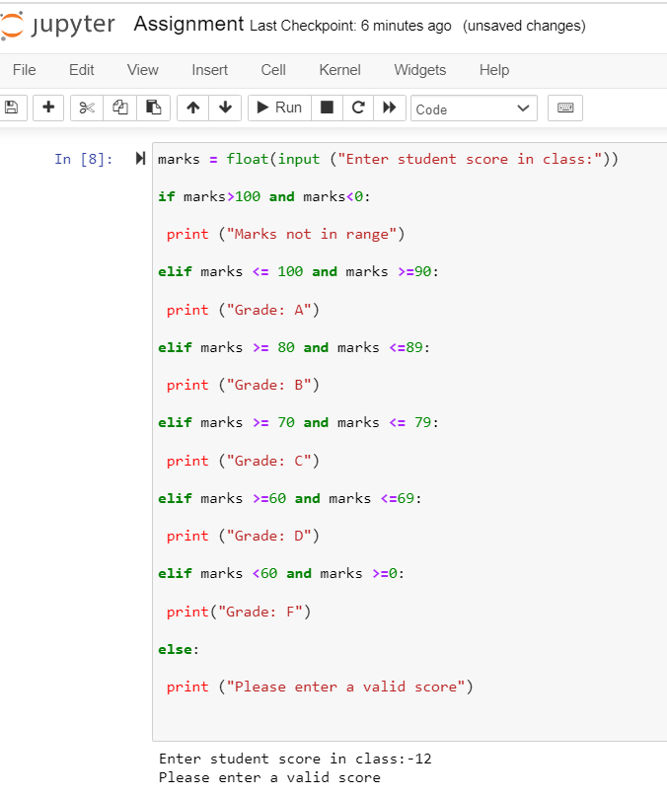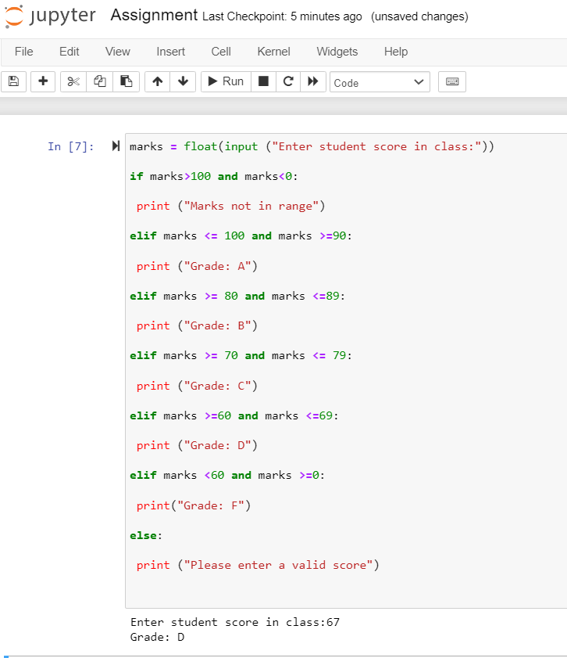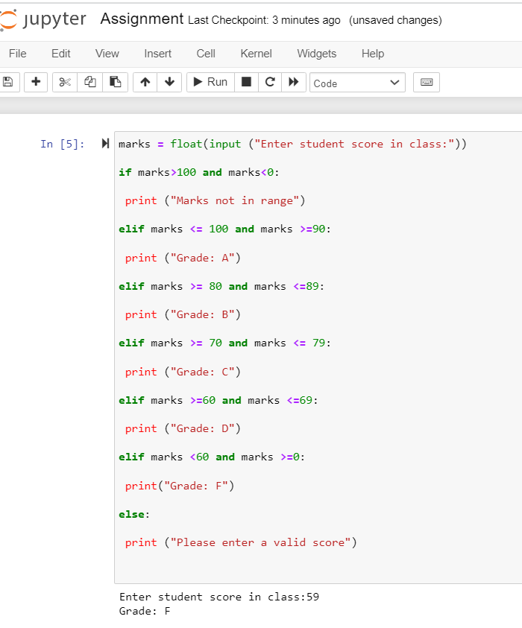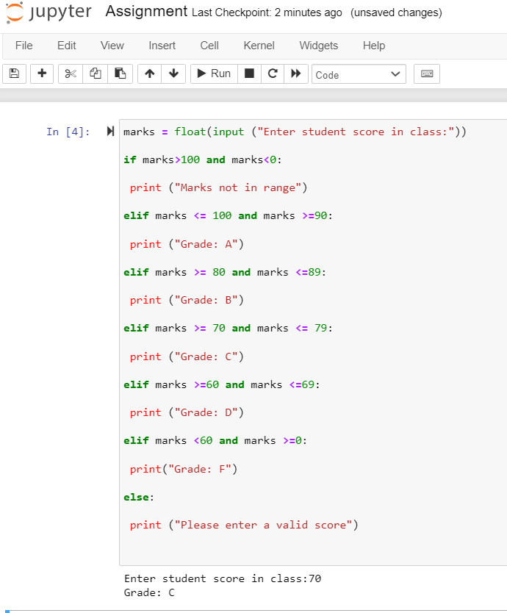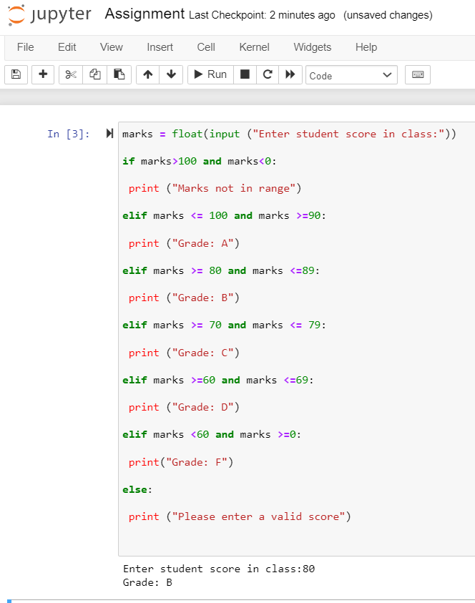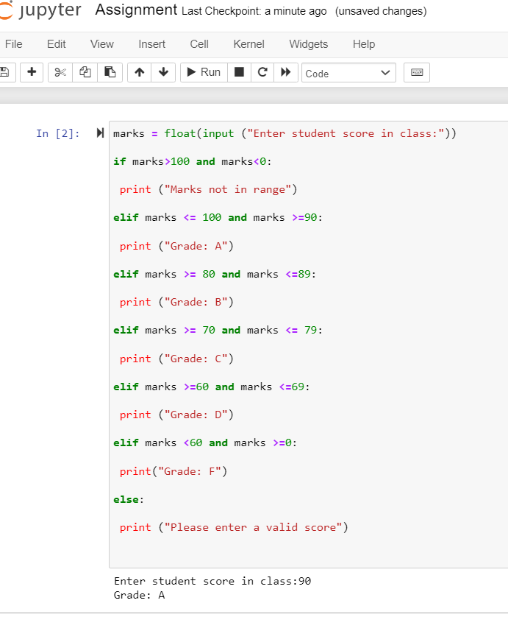

**Description**: In this program, used if statement conditions to generate grades to the marks of the student and for this I used marks variable as input and if statements to generate correct code. So, if It takes marks as input it will deliver the grade as output.

**Google drive link**: https://drive.google.com/file/d/1m5_ODsIClDnR_g0fU6u7f9i6ONqYM1Ut/view?usp=share_link